MEMORANDUM
TO: Board of Directors, Texas HealthLink
FROM: Barakat Adigun, Blessing Anoroh, Denise Atherley, Brandon Chanderban; Data Scientists
DATE: June 25, 2026
SUBJECT: 2024 System-Wide Patient Demand Forecast & Strategic Outlook

Executive Summary
As Texas HealthLink navigates rising patient volumes, staffing shortages, and post-COVID volatility, proactive capacity planning is critical. To support long-term staffing, facility expansion, and budgeting decisions, we conducted a system-wide forecasting analysis of patient demand across our five regional clinics (Temple, Belton, Killeen, Harker Heights, and Waco).
Based on our analysis of monthly visit data from 2016 through 2023, system-wide demand is projected to grow by 3.4% in 2024, reaching approximately 113,164 total visits, driven heavily by demand in Temple and Waco. While the extreme volatility of the COVID-19 period has subsided, established seasonal surges and clinic-specific growth trends remain strong. This memo outlines our expected demand, the strategic risks, and our actionable recommendations for resource allocation.

Historical Context and Business Patterns
Before looking forward, it is essential to understand the underlying behaviors driving patient traffic across our network. To support upcoming facility expansion and budgeting decisions, we analyzed 96 months of historical patient visits (2016–2023) across all five Texas HealthLink clinics:
- Long-Term Trends: Even when isolating the data from pandemic surges, the system-wide demand has grown steadily, with the Temple clinic experiencing the sharpest increase.
- Seasonality: We observed distinct seasonal surges annually, consistently peaking in Winter/Flu season months and dipping in Spring/Summer months.
- The COVID-19 Structural Break: The pandemic introduced significant volatility in early 2020. Our models explicitly account for this temporary shock, by isolating the peak COVID impact (March 2020 through early 2021) mathematically, to ensure our forward-looking projections are based on normalized baseline growth rather than pandemic-era extremes.

Modeling Approach
We used a structured evaluation process to compare multiple statistical models. We tested several methods that capture trend, seasonality, and clinic-specific patterns. To ensure reliability, we "hid" the actual 2023 data from our models, asked the models to predict 2023, and chose the method with the lowest error rate.
Finally, we used a "reconciled" approach. Because the sum of the forecasts for the five individual clinics must equal the forecast for the whole system, our models mathematically share information across clinics to produce a single, unified prediction that aligns at both the local and network levels.

Demand Forecast: 2024 Forecast Outlook
(Note to Board: Please reference Appendix A for individual clinic forecast charts).
For 2024, we project total network demand to follow historical seasonal curves but at an elevated baseline.
- Total Expected 2024 Visits: 113,164
- Peak Demand Month: March (Expected: 9,678 visits)
- Lowest Demand Month: April (Expected: 9,093 visits)

Understanding the Uncertainty Ranges:
Forecasting is about probabilities, not certainties. Each of our projections includes an 80% and 95% confidence interval (the shaded regions on our charts).
- The lower bound represents a mild flu season and slightly slower market growth.
- The upper bound represents an aggressive winter respiratory season combined with high local population utilization. Leadership should view the "expected" line as the primary budgeting target, and the "upper bound" as our stress-test threshold for overflow staffing.
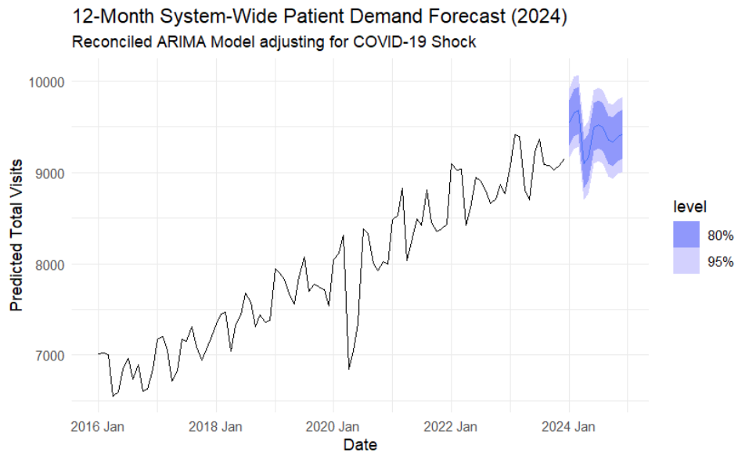
Implications & Risks:
No forecast is perfectly certain. The projected demand volumes introduce several operational constraints that require proactive Board decision-making.
- Staffing Requirements & Burnout Risk: The forecasted peak in March 2024 approaches our maximum daily throughput threshold. Given current staffing shortages, operating at the upper bound of our forecast during this period will lead to severe wait times and provider burnout if float pools are not expanded.
- Facility Capacity Constraints: The forecast indicates that the Temple location is absorbing a disproportionate share of network growth. If this trend holds, this facility will hit physical capacity limits.
- Budgeting and Resource Allocation: Financial planning should anticipate a heavier concentration of variable costs (staff to cover staffing shortages, overtime, supplies, etc.) weighted heavily toward Q1 and Q4, requiring adjusted cash-flow management.

Strategic Recommendations:
Based on the data and risk profiles, we recommend the Board take the following actions:
- Approve Floating Healthcare Nursing Support for Peak Months: Authorize budget for temporary clinical staff specifically earmarked for March through April to absorb seasonal surges without straining full-time staff.
- Initiate Expansion Feasibility Study for Temple Clinic: Given the steep growth curve at this specific location, begin a formal review of facility expansion or the opening of an adjacent satellite clinic to accommodate the demand.
- Adopt "Upper-Bound" Contingency Planning: Direct regional managers to develop overflow protocols (e.g., telehealth options, extended hours) triggered automatically if weekly visit volumes hit the 95% upper confidence bound during Q1 or Q4.

